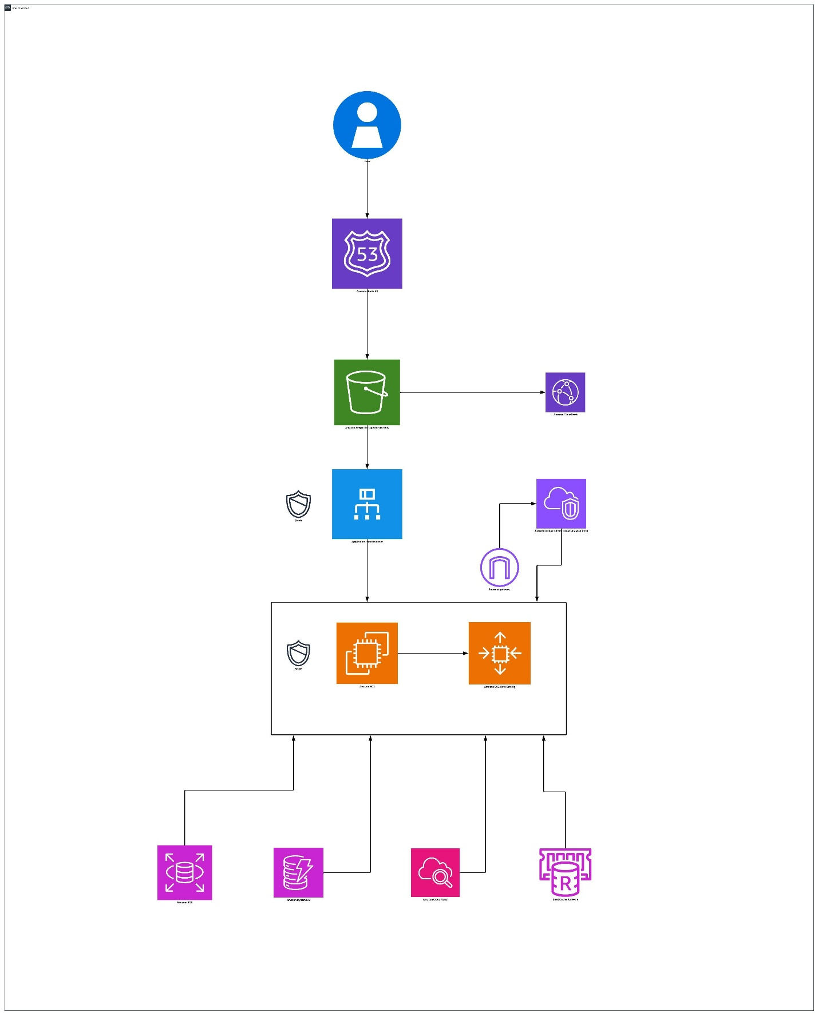

1. User Layer

Component: User
Represents customers accessing the application from browsers or mobile devices.
They interact with your domain name (e.g., www.yourshop.com) hosted on AWS.

2. DNS and Edge Layer

Component: Route 53
- AWS’s Domain Name System (DNS) service.
- Translates the website name to its IP or endpoint.
- Enables global traffic routing — can route users to the nearest region or healthy endpoint.
- Configured with health checks for high availability.

3. Content Delivery & Static Assets Layer

Component: Amazon S3 (Simple Storage Service)
- Hosts static website files (HTML, CSS, JS, product images, etc.).
- Durable (11 9’s durability) and highly available.
- Integrated with CloudFront for faster delivery worldwide.

Component: CloudFront (Content Delivery Network)
- Distributes cached copies of static content from edge locations around the world.
- Reduces latency for global users.
- Also integrates with AWS WAF for edge-level security.

4. Security Layer

Component: AWS WAF (Web Application Firewall)
- Protects against common attacks (SQL injection, DDoS).
- Attached to the Application Load Balancer (ALB).
- Filters malicious traffic before it reaches your backend.

5. Networking & Load Balancing Layer

Component: Application Load Balancer (ALB)
- Distributes incoming traffic evenly across multiple backend instances (EC2s or containers).
- Enables auto-scaling and high availability across multiple Availability Zones.

6. Compute Layer

Component: EC2 Instances / Auto Scaling Group
- The application servers (e.g., Node.js, Python, or PHP).
- Hosted in multiple Availability Zones inside a VPC for fault tolerance.
- Automatically scales up or down based on CPU or traffic metrics.

Component: Amazon VPC (Virtual Private Cloud)
- Provides network isolation and segmentation for your application.
- Includes Internet Gateway for web access.

7. Data & Storage Layer

Component: Amazon Aurora (or RDS)
- Primary relational database for transactional data (orders, users, payments).
- Automated backups and read replicas for scalability.

Component: DynamoDB
- NoSQL database for fast access to non-transactional data (shopping carts, sessions, product catalogs).
- On-demand scaling and high performance.

8. Monitoring, Logging, and Resilience
- CloudWatch – tracks metrics for EC2, RDS, and Auto Scaling.
This AWS architecture was designed for high availability and global scalability by integrating Route 53 for DNS routing, CloudFront for content delivery, and Auto Scaling with Elastic Load Balancing to manage variable user traffic efficiently. Data durability and performance are achieved through a combination of S3 for static assets, RDS for transactional data, and DynamoDB for session or NoSQL storage. To ensure security, resilience, and cost optimization, the design employs VPC isolation, IAM for access control, CloudWatch for proactive monitoring, and right-sized EC2 instances to minimize overhead while maintaining reliability.

